Week 9 Assignment - screenshots

Rakesh Teja P V

Add flight by admin:

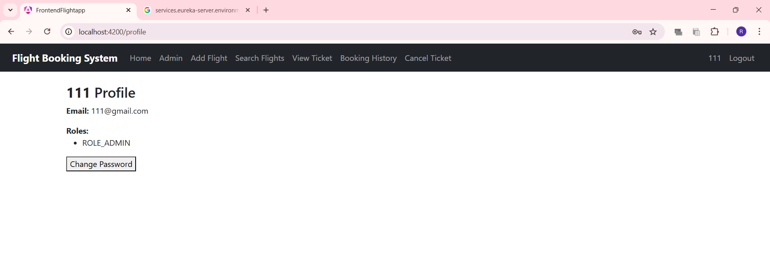

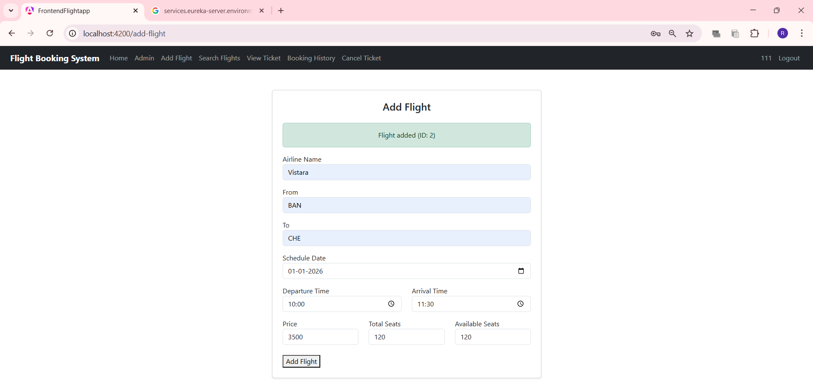

Same arrival and departure places

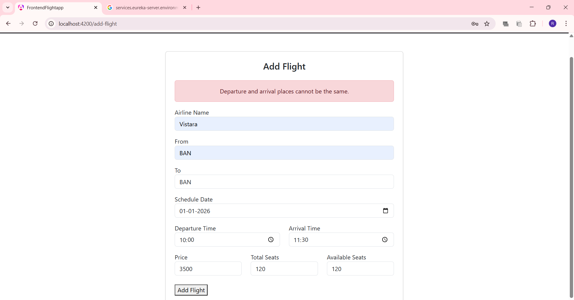
Arrival Time before Departure Time

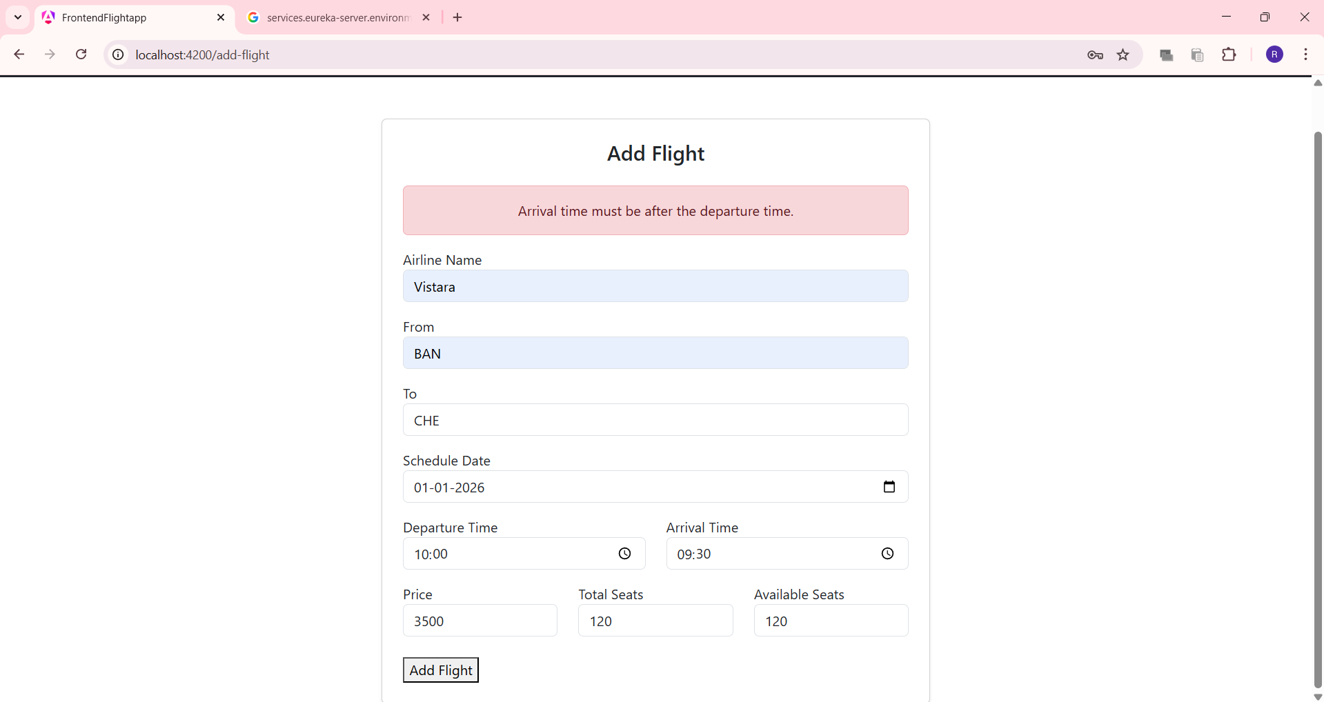

Changed Password successfully

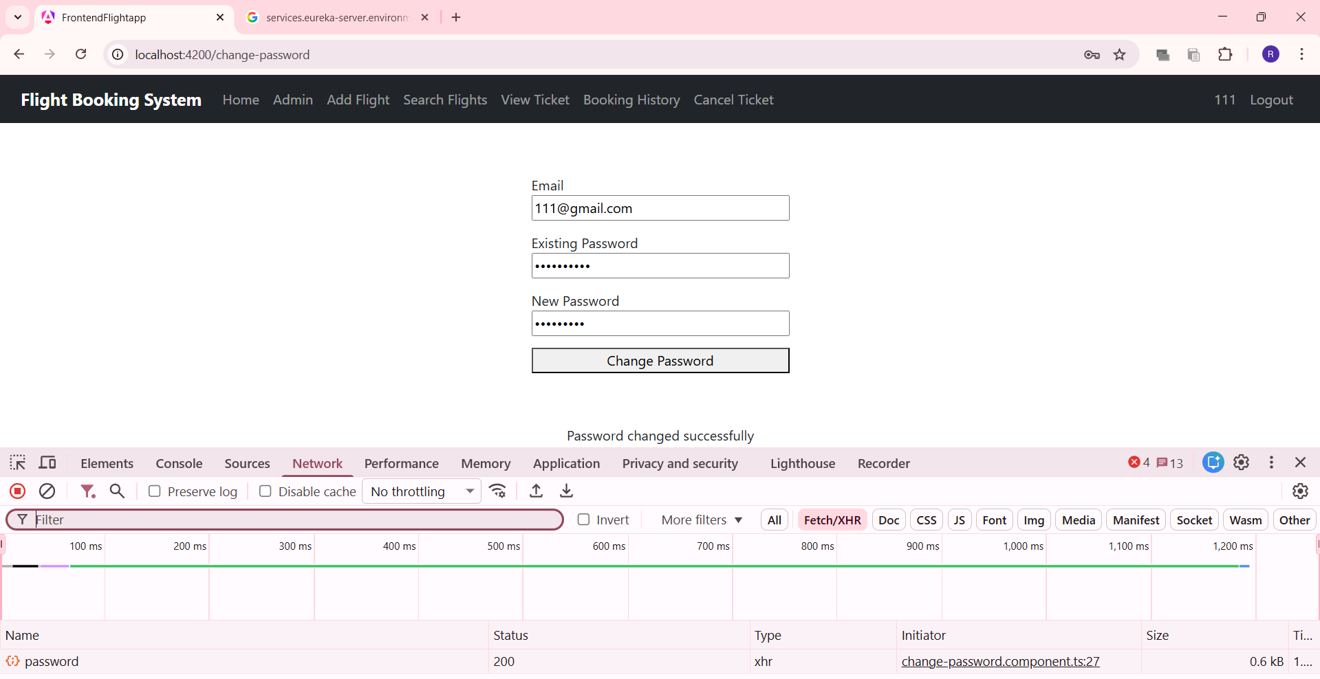

Incorrect Email Id validation

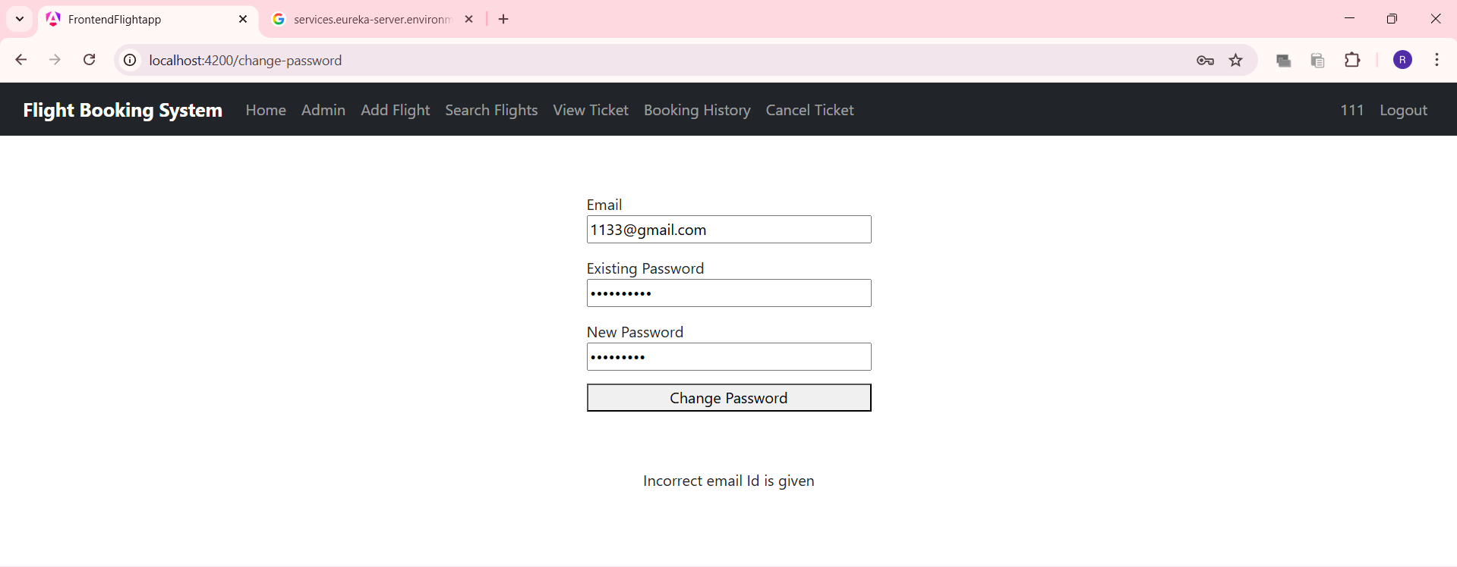

Incorrectly typed existing password

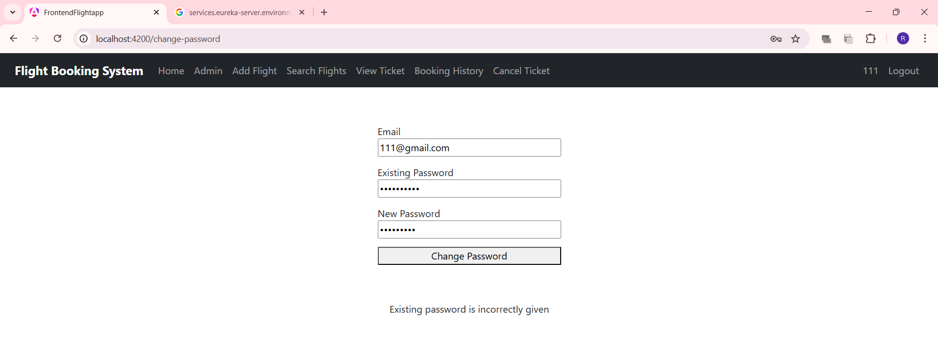

Docker deployed with different application.properties file

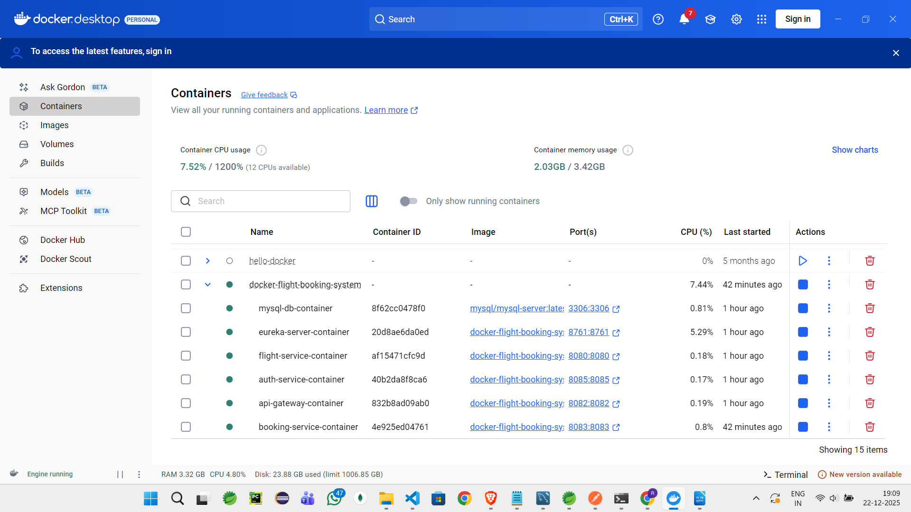
- Optimized Docker deployment by running mvn package and then copying it to docker instead of building it inside docker (refer github)

- Used spring profiles in docker-compose.yml to select application-docker.properties (refer github)

